LIMITED NO WAKE COVE RESTRICTIONS
(FOR VESSELS 40' IN LENGTH AND GREATER)
FREQUENTLY ASKED QUESTIONS (FAQ)
What is the limited no wake restriction?
In 2018, Missouri's legislature passed a law which allowed for coves under 800' in width to be restricted to no wake for vessels 40' and greater. The law required a regulation, or rule, to be created by the Department of Public Safety to indicate how this limited no wake restriction would be implemented. The Water Patrol Division was tasked with creating the regulation, since the Water Patrol Division has statutory authority to mark the waters of the state with regulatory markers and navigational aids (RSMo 306.124).
What does the regulation on limited no wake restrictions say exactly?
11 CSR 50-3.010 (3) O: Applications may be submitted by property owners located on a waterway narrowing to less than eight hundred feet (800’) in width to restrict vessels forty feet (40’) in length or greater to no wake. To ensure uniformity, the eight hundred feet (800’) width eligibility applies to coves or main channel areas. Waterways eight hundred feet (800’) or greater in width will not be considered for this restriction unless the volume of boating traffic is significantly disproportionate to similar areas on the same body of water, or boating traffic accident data support the need for the restriction. This restriction may be indicated by buoy markers, signage on docks, or signage on the shoreline, as specified in the permit by the Water Patrol Division. Applications where signage is a requirement on docks or shoreline property, are to include proof of ownership and written consent from each owner where signs will be posted. Applications under this clause will be heard by the Water Patrol Division at a public hearing. Petitions from property owners in the affected area are unnecessary for this limited no wake restriction. Approval is based on the enhancement of public safety in the proposed area and testimony provided at the hearing. If approved, the permit holder is responsible for maintaining the buoys and/or signage as indicated in the permit.
How do property owners apply for the limited no wake restriction?
The limited no wake restriction may be applied for on the Water Patrol Division’s website. Limited no wake restriction applications will be heard at the January, March & May public buoy hearings each year. The application, application deadline and hearing dates are on the division’s website at the link below:
https://www.mshp.dps.missouri.gov/MSHPWeb/WaterPatrol/buoyInformation.html
How will limited no wake areas be marked for boaters?
Due to potential conflicts with traditional floating buoy markers, the limited no wake areas will be marked with signage placed on each side of the waterway on docks or the shoreline. An imaginary line that runs between the signs will indicate the starting point of the restricted area. The signs are only to be posted where the limited no wake restriction begins. The signs will be a minimum 4' wide by 4' in height. The markings on the sign will comply with the prescribed marking system the Water Patrol Division utilizes for traditional floating buoys/signs. It’s important for boaters to use the interactive map on the Water Patrol Division’s homepage, in conjunction with the signs, to better identify these coves. A sample of a limited no wake cove sign is located below:
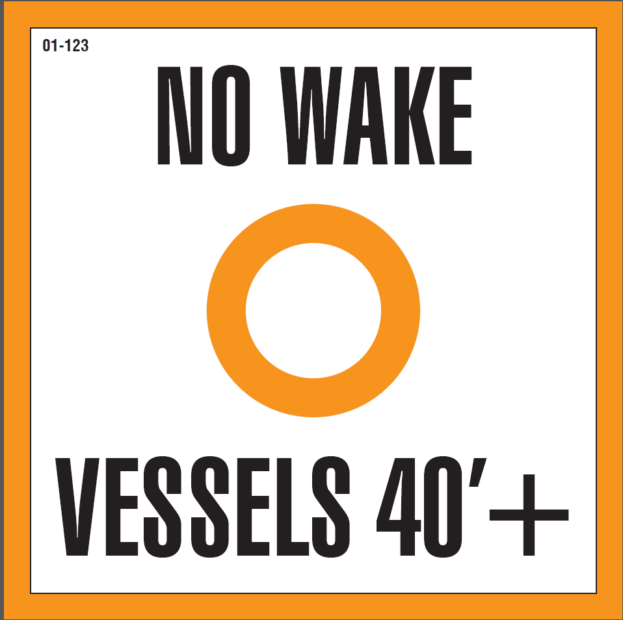

What other methods will be utilized to make large vessel owners aware of the limited no wake restriction areas?
The Water Patrol Division’s homepage contains a link to an interactive map of Lake of the Ozarks. Ameren Missouri’s Shoreline Management Office provides the map to indicate where these limited no wake areas are located. The map can be accessed by computer or smartphone. The map allows boaters to zoom in on specific portions of the lake where they boat to determine which coves are affected by the limited no wake cove restriction. Limited no wake coves are shaded in yellow on the map. Again, the no wake restriction for limited no wake coves only applies to vessels 40’ in length or greater. The link to the map is located below:
https://www.tgigis.com/Html5ViewerSMS/index.html?viewer=Aerial.Aerial
Education for boaters will be supplemented utilizing media and social media resources. Interaction with the boating public by marine troopers on the water will be a form of education as well.
Will any coves wider than 800' be granted the limited no wake status?
Coves or waterways greater than 800' in width may be designated as a limited no wake area if the boating traffic in the area is disproportionate to areas of similar size on the same body of water. Accident data justifying the implementation of a limited no wake area would also be a consideration. Ultimately, the enhancement of safety on our waterways is the goal of these restrictions.
What does the application process entail?
The current buoy application does have the option of applying for the limited no wake restriction. In addition to filling out the form, applicants must provide a diagram of the area where they are requesting the signs to be placed. A letter of approval from the property owners where the signs are to be placed is required, in addition to proof of ownership for those property owners. Proof of ownership may be determined with a copy of their dock permit or by real estate tax receipt. The link to the Water Patrol Division’s webpage containing the buoy application is below:
https://www.mshp.dps.missouri.gov/MSHPWeb/WaterPatrol/buoyInformation.html

